Working Prototype Lowe Hackathon

Main screen

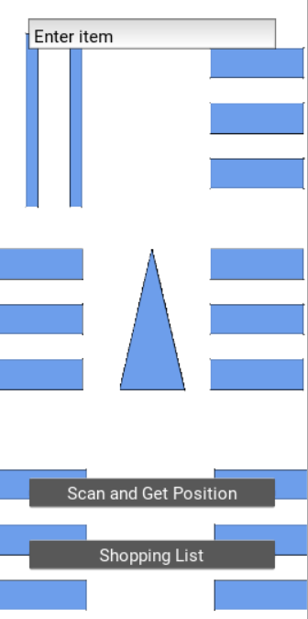

The screen here shows a custom map of a shop, the blue colored shapes are shelves where you have items.

The above text input lets you input any item you would like to buy and it would search in the database and get a route

Scan and Get Position: You can scan a barcode of an item or one which is placed throughout the store to help users get around

Shopping listL It shows all the items to buy.

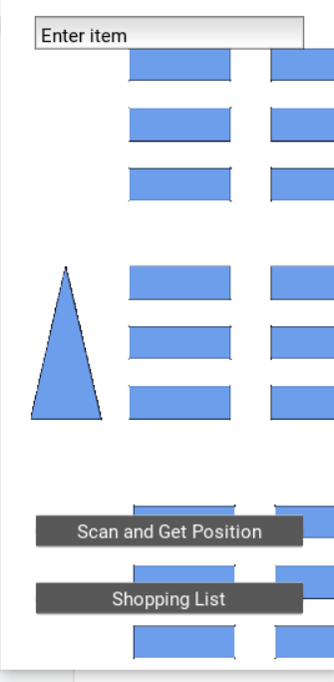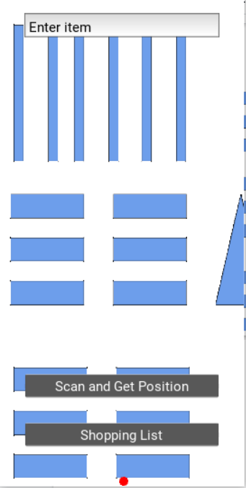

You can use your fingers to move around the map. Zooming can also be added.

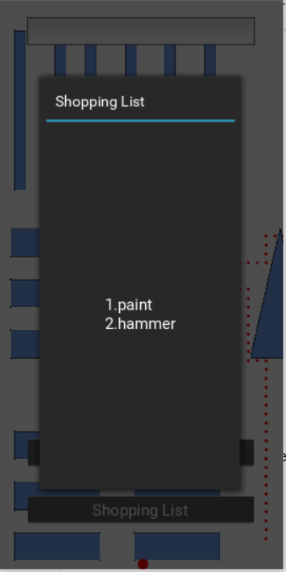

A view of the shopping List

Adding items to the list and finding paths to it.

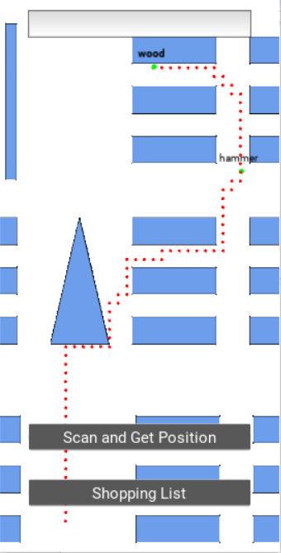

The program sees hammer is the first item to pick up and hence go there and then to the wood. If we are to add paint which is located closer to the customers current position it goes to paint then to wood as it is closer to wood than hammer.

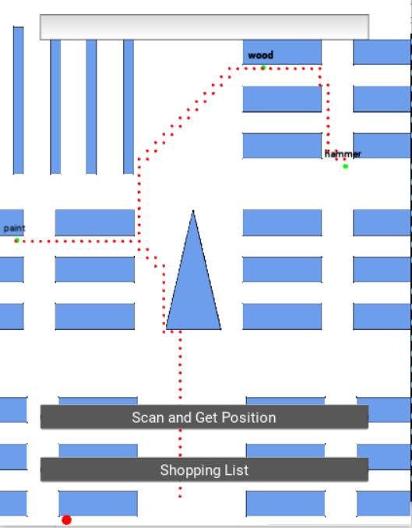

Paint to

Wood

Then to

Hammer

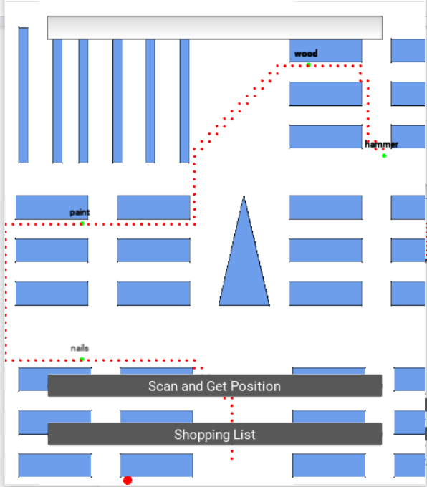

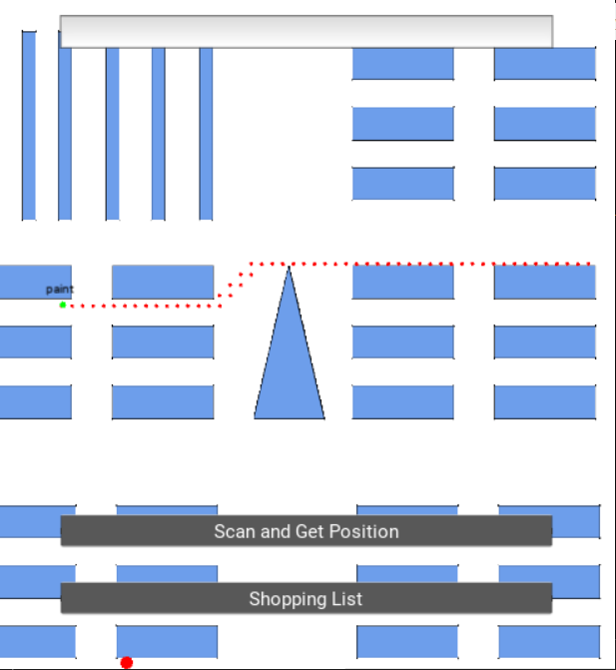

Map calculated on from a different location.

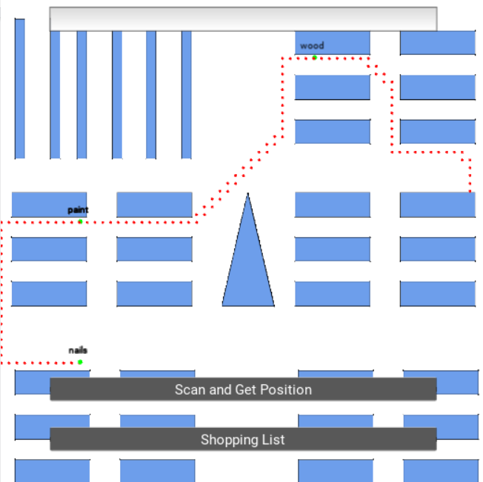

The algorithm is based on A star but a slightly modified one. Each item is located in a shelf and each shelf has two or more entry points.

First the algorithm finds the nearest entry point from the current location and travels to there, then goes to the item location.

Input to the algorithm: (Current Location, item_location = [(location of item), if in stock, shelf_details = (two entry points to the shelf by default)]